# C2- S5 - PRACTICE

*NOTE: check your* ***THEORY slides*** *to answer those questions!*

# EXERCISE 1 – GOOGLE CLASSROOM DATABASE

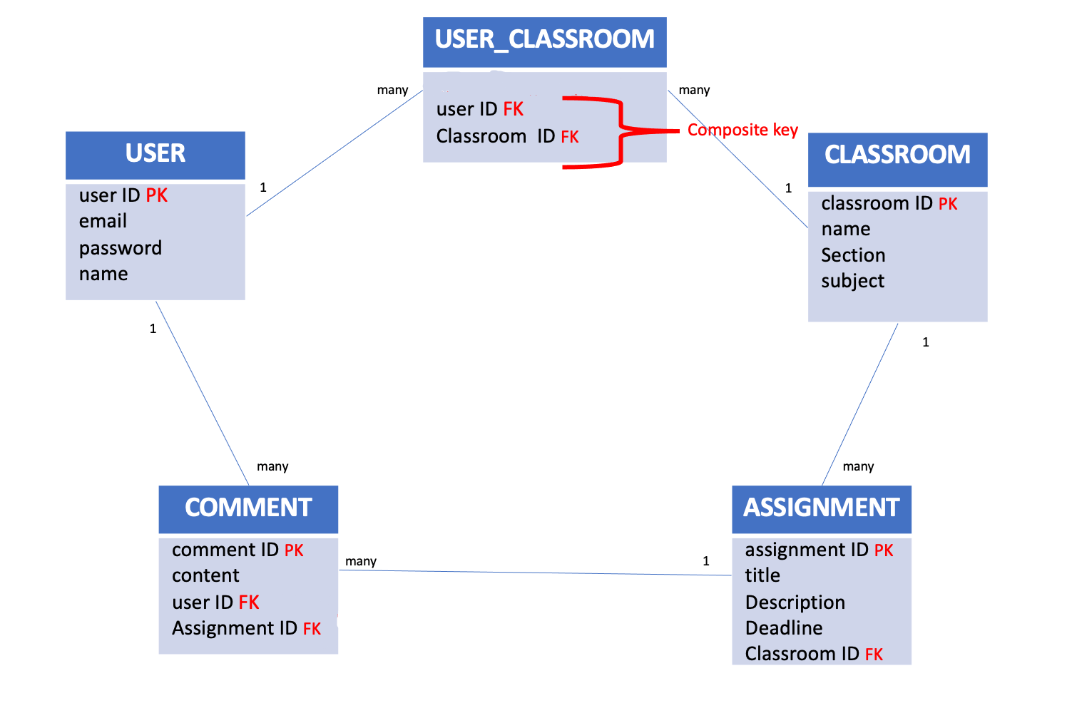

Here is the Entity Relation Diagram of the Google Classroom Database you designed in Chapter 1. You are now going to put it in MySQL!

**Q1 –** Write a statement to create the Google Classroom database, and to tell MySQL you are now working with it.

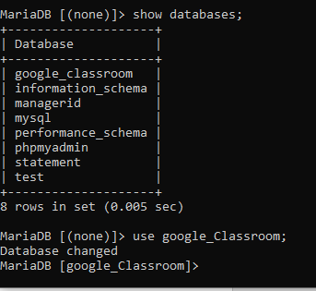

**Q2** – For each table (USER, USER_CLASSROOM, CLASSROOM, ASSIGNMENT, COMMENT), complete the following arrays, by specifying for each attribute:

* + The attribute type (SQL type) and size
  + Can be null or not?
  + Is a primary key or foreign keys?
* **USER TABLE**

|  |  |  |  |
| --- | --- | --- | --- |
| Attribute name | Type / size | Can be Null? | Key |
| User ID | int | NO | PK |
| email | Varchar(200) | YES |  |
| Password | int | NO |  |
| name | Varchar(100) | YES |  |

**USER_CLASSROOM TABLE**

|  |  |  |  |
| --- | --- | --- | --- |
| Attribute name | Type / size | Null? | Key |
| User ID | Int | NO | FK |
| Classroom ID | int | NO | FK |
|  |  |  |  |

**CLASSROOM TABLE**

|  |  |  |  |
| --- | --- | --- | --- |
| Attribute name | Type / size | Null? | Key |
| classroom | int | NO | PK |
| name | Varchar(100) | NULL |  |
| Section | Varchar(150) | NULL |  |
| subject | Varchar(200) | NULL |  |

**ASSIGNMENT TABLE**

|  |  |  |  |
| --- | --- | --- | --- |
| Attribute name | Type / size | Null? | Key |
| Assignment ID | int | NO | PK |
| title | Varchar(200) | NULL |  |
| Description | Varchar(200) | NULL |  |
| Deadline | Varchar(100) | NULL |  |
| Classroom ID | Varchar(200) | NULL | FK |

**COMMENT TABLE**

|  |  |  |  |
| --- | --- | --- | --- |
| Attribute name | Type / size | Null? | Key |
| Comment ID | int | NO | PK |
| content | Varchar(100) | NULL |  |
| User ID | int | NO | FK |
| Assignment ID | int | NO | FK |

**Q3** – Write the SQL statement to create the 5 tables with appropriate properties.

WARNING: Create the tables in the right order to respect the Foreign Key constraints.

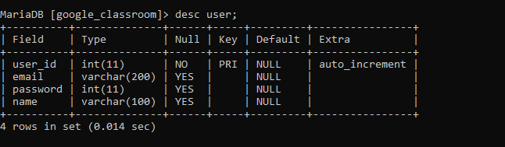

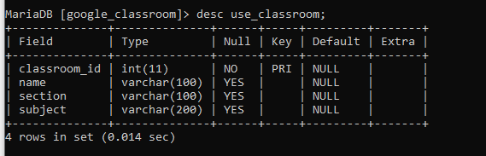

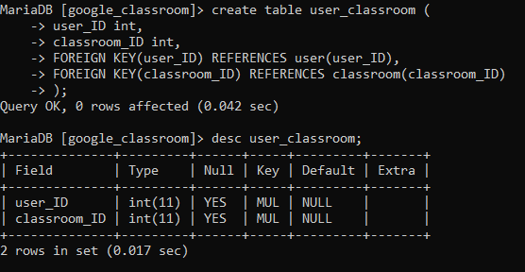

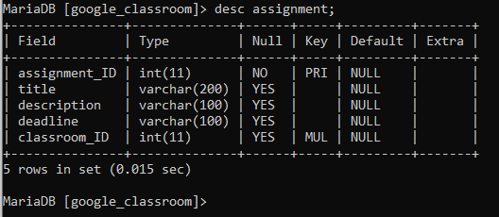

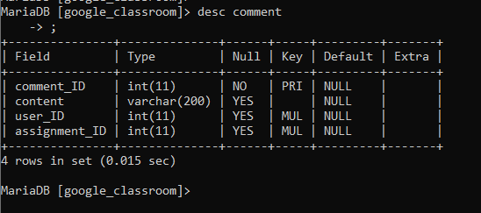

**Q4 –** Write statements to insert at least 3 records in each table.

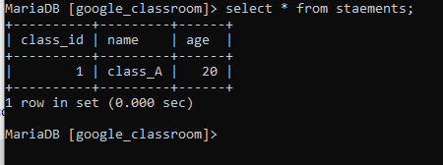

EXERCISE 2 – FOODPANDA DATABASE

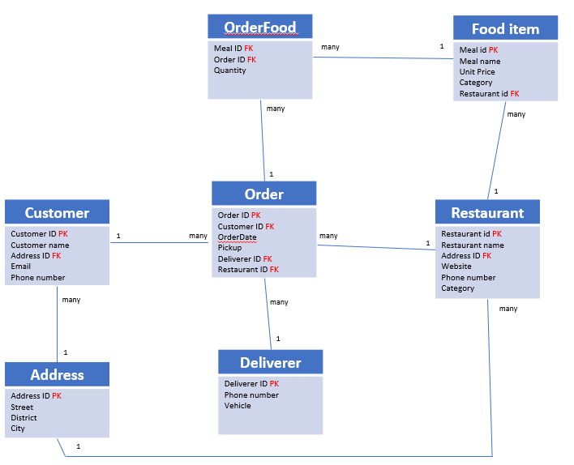

Here is the Entity Relation Diagram of the Foodpanda Database you designed in Chapter 1. You are now going to put it in MySQL!

**Q1 –** Write a statement to create the Foodpanda database, and to tell MySQL you are now working with it.

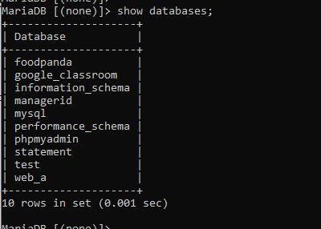

**Q2** – For each table of the database, complete the following array, by specifying for each attribute:

* + The attribute type (SQL type) and size
  + Can be null or not?
  + Is a primary key or foreign keys?

1. Address Table

|  |  |  |  |
| --- | --- | --- | --- |
| Attribute name | Type / size | Null? | Key |
| address_ID | int | NO | PK |
| street | Varchar(100) | NULL |  |
| District | Varchar(100) | NULL |  |
| City | Varchar(100) | NULL |  |

1. Customers Table

|  |  |  |  |
| --- | --- | --- | --- |
| Attribute name | Type / size | Null? | Key |
| Customer | int | NO | PK |
| Cutomer_name | Varchar(100) | NULL |  |
| Address_ID | int | NO | FK |
| email | Varchar(200) | NULL |  |
| Phone_number | int(20) | NO |  |

1. Deliverers Table:

|  |  |  |  |
| --- | --- | --- | --- |
| Attribute name | Type / size | Null? | Key |
| Deliverer_ID | int | NO | PK |
| Phone_number | Varchar(15) | NULL |  |
| vehicle | Varchar(100) | NULL |  |

1. Restaurants Table:

|  |  |  |  |
| --- | --- | --- | --- |
| Attribute name | Type / size | Null? | Key |
| Restaurant_id | int | NO | PK |
| Restaurant_name | Varchar(50) | NULL |  |
| Address_ID | int | NO | FK |
| website | Varchar(100) | NULL |  |
| Phone_number | int(15) | NO |  |
| category | Varchar(100) | NULL |  |

1. Food_items Table:

|  |  |  |  |
| --- | --- | --- | --- |
| Attribute name | Type / size | Null? | Key |
| Meat_id | int | NO | PK |
| Meal_name | Varchar(100) | NULL |  |
| Unit_price | int | NO |  |
| category | Carchar(100) | NULL |  |
| Restaurant_id | int | NO | FK |

1. Orders Table:

|  |  |  |  |
| --- | --- | --- | --- |
| Attribute name | Type / size | Null? | Key |
| Order_id | int | NO | PK |
| Customer_id | int | NO | FK |
| orderdate | datetime | NULL |  |
| pickup | Varchar(100) | NULL |  |
| Deliverer_id | int | NO | FK |
| Restaurant_id | int | NO | FK |

1. Order_food Table:

|  |  |  |  |
| --- | --- | --- | --- |
| Attribute name | Type / size | Null? | Key |
| Meal_id | int | YES | FK |
| Order_id | int | YES | FK |
| quantity | Varchar(100) | NULL |  |

**Q3** – Write the SQL statement to create the tables with appropriate properties.

WARNING: Create the tables in the right order to respect the Foreign Key constraints.

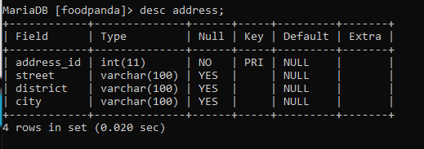

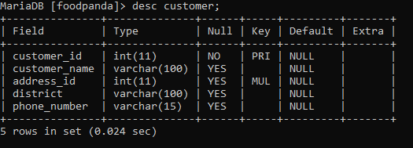

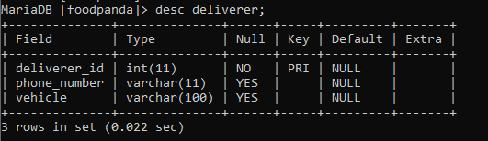

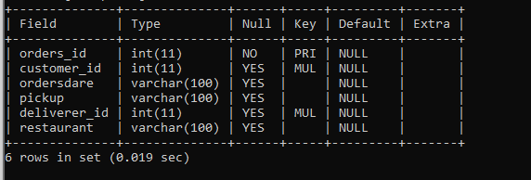

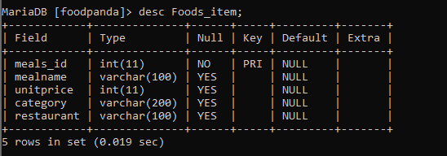

**Q4 –** Write statements to insert between 2 and 4 records in each table.